**\*Link to UiPath**

[RPA Certification - Advanced RPA Developer | UiPath](https://www.uipath.com/learning/certification)

*Robotic Enterprise Framework (R.E. Framework)

Best for large/ big projects

*Simple small project: Start with blank. Blank = Process

*To download extension:

‘Tools’ (left list)🡪 then select whichever extension needed. Eg: extension for browser

*To start project:

Open up UiPath 🡪 ‘start’ (left list) 🡪 select ‘process’ 🡪 name project, select location to save.

*To enable packages of different file format:

‘Manage packages’ (top ribbon), type in keywords to find package, then select from the drop down list of support package.

*Per new “sheet” in the project is a new “file”, if want to run selected file, select “run file”.

*Line Break: Environment.NewLine

*Disable/ Comment out activity: Select activity 🡪 right-click, ‘disable activity’

*Enable back activity: Select on ‘comment out’ 🡪 right-click, ‘enable activity’

*Hello World in message box

*Understanding Variables (module 2):

Data: is information, text, string, numbers, input etc.

Assign data into variables, store data into a variable.

*Array:

Name= {“peter”, “john”, “harry”, “tom”} =4elements

Data inside are called elements

Address = index number

Element always start from 0

Name(0) = “peter’

*Integer in UiPath:

Int32= 4byte (smaller range than int64)

Int64

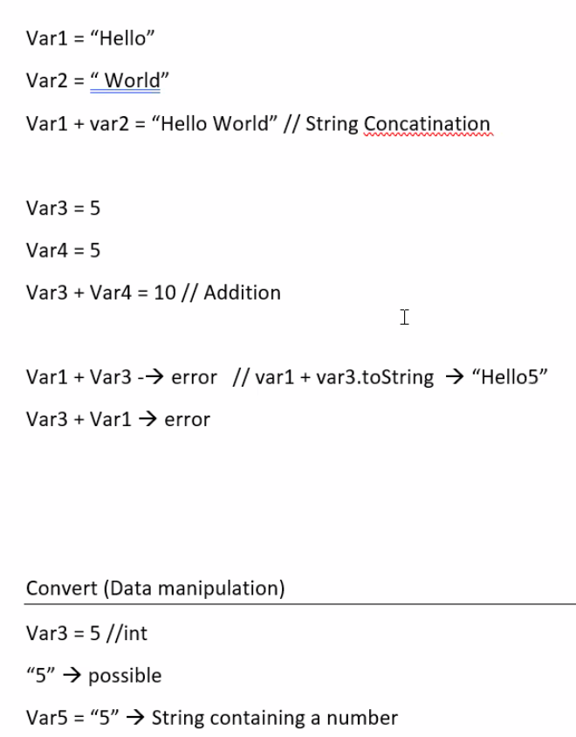

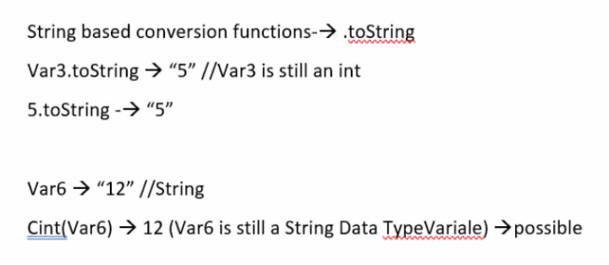

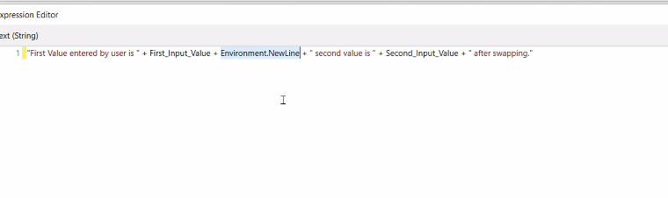

*Assign value:

If value is undefine (by default):

Integer= 0

String= blank

Boolean= False

*WriteLine works the same as message box, will show result in output window (bottom left).

*Output on right side will show the list of activities used in the project.

*Short cut to set variable: CTRL K (enter variable name into ‘input dialog’ under ‘value entered’)

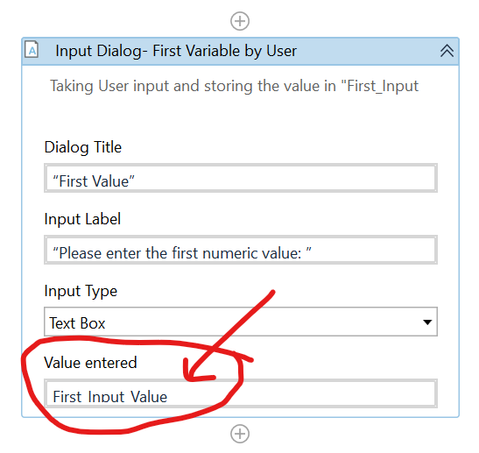

*Variable data type: To select other date type🡪 browse drop down list.

For double: select ‘mscorlib’

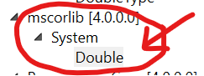

*Arguments:

Defines data to be passed from one workflow to another.

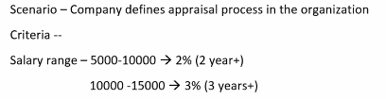

-Workflow A:

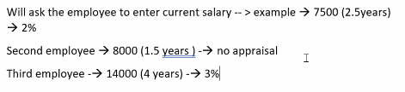

-Workflow B:

-Workflow C:



*Using ‘multiple choice’ in input dialog: (if below 3choices, will be in bullet list)

*Workflow/ Invoke workflow file

*Array

NamesList = {“John”, “Peter”, “jane”}

-Use {}

-Name of array is case-sensitive same as variables

-Size of array is the number of elements (3)

-Array elements cannot mix string and integer

-First element index start with 0 (Peter)

-Array are fixed size, cannot be manipulated, cannot be added or remove.

-Array in UiPath 🡪 create under variables 🡪 select type of array under ‘Array of [T]’

🡪 String for alphabet/ Int32 for numbers

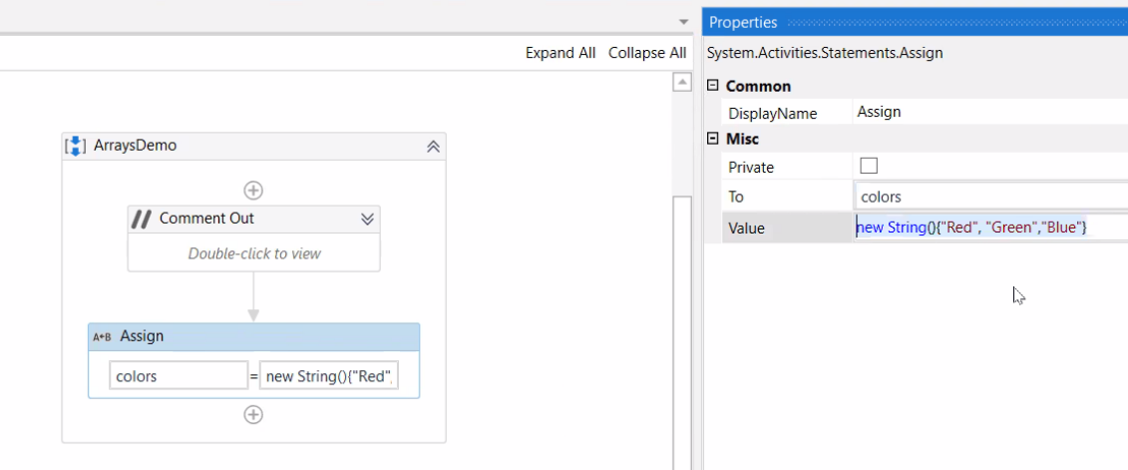

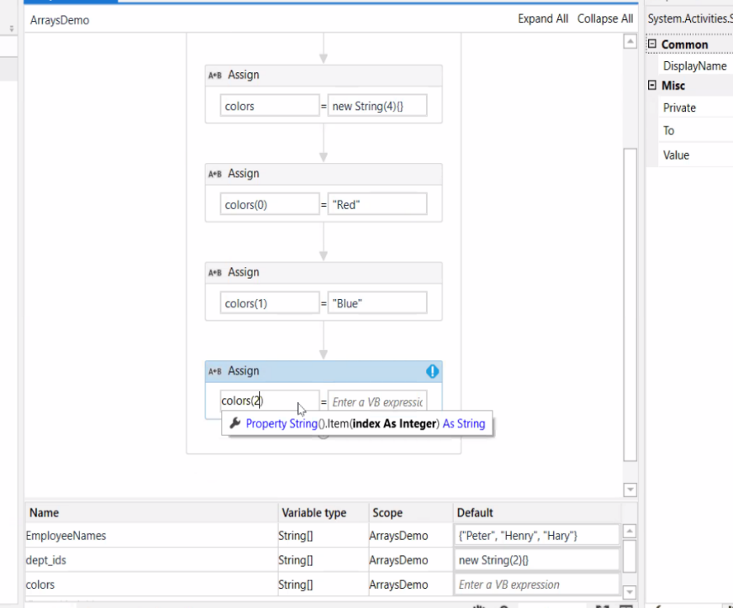*Use ‘Assign’ to set array:

-Set variable 🡪 (4) means total 5 elements

-Then assign each color 1 by 1

*to print dept of array

*List:

NamesList = [“john”, “peter”, “jane”]

-Use []

-List can be manipulated, cannot be added or remove

-Name of list is case-sensitive